Limited Purpose Aquaculture License (LPA) Workbook

Completed in collaboration with the Maine Shellfish Learning Network (MSLN) and Manomet
Table of Contents

Introduction 2
Types of licenses 3
Applying for an LPA 4
Before Applying 4
Requirements for LPAs 4
Information for LPA Licenseholders 5
Timing 6
Application Forms 8
Filling out the Application 9
General Information 10
Species and Source of Stock 11
Water Quality Information 12
Coordinates 13
Site characteristics 13
Existing Uses 14
Vicinity Map 14
Gear Description 15
Overhead View and Cross-Sectional View of Gear Layout 15
Required Signatures 15
Riparian Notification 16
Application Signature 16
Submitting your Application 17
Renewal Process 17
Final Recommendations 18

Introduction

This workbook is designed to help municipal shellfish committees apply for Limited Purpose Aquaculture (LPA) licenses. These licenses are required for various conservation projects, particularly focused on reseeding or revitalizing wild spawning for shellfish while using aquaculture technology or structures. This workbook was created collaboratively, with members of the Maine Department of Marine Resources (DMR), select municipal shellfish committees, and others involved in the shellfish industry providing materials and comments that shaped the final product. This included providing previous application materials highlighting where more clarity was needed on the application, interviews where collaborators discussed the process overall, and feedback on the workbook as it developed.

This workbook moves section by section of the application, including photos, videos and hyperlinks to various parts of the DMR website. To use this workbook, please first access application materials from the DMR website (to find them turn to pg. 5). Starting on pg. 6, the workbook will describe section by section a more comprehensive breakdown of where to access information and how to answer the application questions.

As you start your application process, please read both the application materials and this workbook carefully.

For questions about the workbook please contact:

Gabrielle Hillyer
University of Maine Orono
gabrielle.hillyer@maine.edu

Marissa McMahan
Manomet
mmcmahan@manomet.org

Bridie McGreavy
University of Maine Orono
bridie.mcgreavy@maine.edu

For questions about the limited purpose aquaculture license process please contact:

Flora Drury
Department of Marine Resources
flora.drury@maine.gov

Types of licenses

There are multiple types of aquaculture leases and licenses in the State of Maine, including standard leases, experimental leases, and limited purpose aquaculture license (LPA). An LPA is considered the simplest and most accessible license for municipal conservation projects that will not exceed 400 square feet in size. This includes the deployment of floating trays, floating bags (such as oyster bags) and the use of floating upwellers (a floating system for growing shellfish). For any project that exceeds 400 square feet, an experimental or standard lease is required, or multiple LPAs.

Standard

A standard aquaculture lease is the most permanent and onerous lease to obtain for aquaculture companies and aquaculturists. This lease can be up to 100 acres of subtidal or intertidal space and last for up to 20 years. The application fees for non-discharge leases total $1,500. Afterwards people who hold leases pay $100 per acre each year. The application process includes: a pre-application meeting, a public scoping session, site visit(s), a public hearing, and a final decision set forth by the DMR Commissioner's office.

Experimental Lease

An experimental lease permits the lease holder to culture finfish, shellfish, and marine algae on up to 4 acres for commercial or scientific purposes. Experimental leases for commercial purposes cannot be renewed after 3 years. There is a $100 application fee and then an additional fee every year owned ($100/acre). There is a public comment period that is required, and public hearings may be held.

Limited Purpose Aquaculture License (LPA)

An LPA is designed to be more accessible than the standard or experimental lease for individuals to test aquaculture methodologies in the intertidal and subtidal. For communities, this is the fastest option to get licenses for conservation projects. An LPA authorizes the use of aquaculture gear on up to 400 square feet for 1 year. When approved, municipalities can conduct conservation activities such as deploying floating structures. There is no public scoping session or hearing required, however there are a number of people, including the DMR Division of Aquaculture, the Army Corp of Engineers, and the local municipal shellfish committee who need to approve the application before activities can be conducted if the area is in the intertidal. In general, the application process can take between 30 and 90 days.

Applying for an LPA

Before Applying

Before applying for an LPA please consider that you will need a very detailed plan for your proposed license area. This includes what gear will be used, how large the gear may be, what orientation the gear will have within the LPA, and if there will be any seasonal changes to that gear orientation. In addition, there is a non-refundable $100 application fee for residents, and $400 for non residents, and the entire application approval process can take 30 days or longer. If approved, you will also need to renew your LPA each year, as each LPA license expires on December 31st. To renew an LPA, you need to fill out renewal documents, pay a renewal fee ( (sent by DMR earlier in the year) as well as complete an educational course. If the renewal process is not completed, all gear needs to be removed from the LPA license area before December 31st.

Requirements for LPAs

There are various requirements for LPAs described on page iii and page iv of the application. These requirements include but are not limited to:

- Total number of licenses: No more than four licenses can be held by any one person or municipal shellfish committee.
- Density limit: There can only be four LPAs within a 1,000 ft radius.
- Total number of assistants: Only 3 people can be declared assistants. Students can also conduct work on the LPA, however, the person who holds the license must represent an educational institution.
- Signatures: All applications in the intertidal (above the extreme low water mark) must be signed by the shellfish committee chair (if there is a shellfish committee).
- Water quality considerations: LPA license sites for shellfish may not be within 300 feet of any areas classified as “Prohibited” and can only be located in areas that are classified as “Approved” or “Conditionally Approved”, except for the sole culture of seed. To find out about the classifications in your area, you can visit the DMR web portal, here. Make sure when using the map that in the key on the right, you have clicked “Current NSSP Classifications” to see closed areas.
- Habitat: LPAs cannot be in any areas declared “Essential Habitat” by the Department of Inland Fisheries and Wildlife, or within 660 ft of eagles nests. You can check for an eagle's nest on this map by clicking here.
- Landowner notification: You are also required to notify riparian landowners within 300 feet of the proposed LPA by sending, via certified mail, a copy of the LPA application, including information about how riparian owners can submit comments to DMR regarding issuance or renewal of the license. Landowner data is usually available on municipal websites usually under a tax assessor section. Please note when reviewing aquaculture applications DMR considers riparian ownership to extend to the Mean Low Water (MLW) line or 1650 feet from shore.
- Army Corps Permit: A permit from the U.S. Army Corp of Engineers is required before conducting any activities in the license area including deploying any gear. The DMR will forward your application to the Army Corp once it is received.

Information for LPA Licenseholders

- No Discharge: The licensed activity described in the application cannot add any foreign substances to the water within the license area.
- Carry a Copy of LPA License: License holders and named assistants are the only people legally allowed to handle the gear within the license area. You must each carry a copy of the LPA license whenever you are engaged in activity on the LPA site.
- Restriction on Harvest: LPAs in a prohibited area can only be used for seed and harvest of shellfish is prohibited. An LPA does not qualify for exemptions from biotoxin closures.
- Record-Keeping and Annual Report: You must maintain accurate records of any transport, transfer, harvest, and monitoring within the license area. You need to keep these records available for inspection for at least two years and submit an annual report to the DMR Commissioner. For more information, please review the LPA application document, page iv.
- Site Marking: The corners of your LPA site must be clearly labeled with buoys supporting letters at least 2 inches high spelling “Sea Farm” and your Site ID. For more information please visit the link below, https://www.maine.gov/dmr/aquaculture/forms/documents/markingrequirements71421.pdf
- Maintenance Standards: All aquaculture gear must be maintained and kept in a fully operational condition. You should also proactively ensure that bird or mammal waste does not accumulate on gear and adversely impact water quality on or around your LPA.
- Contact the Coast Guard: You must contact the U.S. Coast Guard Private Aids to Navigation Office to determine if a Private Aid to Navigation is needed to mark your site. The best first step is to contact Steve Pothier at 617-223-8347 or steven.r.pothier@uscg.mil. To begin the application process, go to http://www.usharbormaster.com and register. Send DMR a copy of any Coast Guard marking requirements.

Timing

The application process can take anywhere from 30-90 days from start to finish, including filling out the application, submitting it, and then allowing adequate time for the DMR and Army Corp permit approval process. This means that municipal shellfish committees should plan ahead, in order to have the permits in hand before beginning any projects.

Please note - DMR Staff recommends applying over the winter (January- February) for spring projects to provide adequate time for the application process before starting the project. The DMR does not accept new applications starting October 1st prior to renewal (December 31st).

On the next page, we have included a timeline that highlights some of the details for each step in the application process.
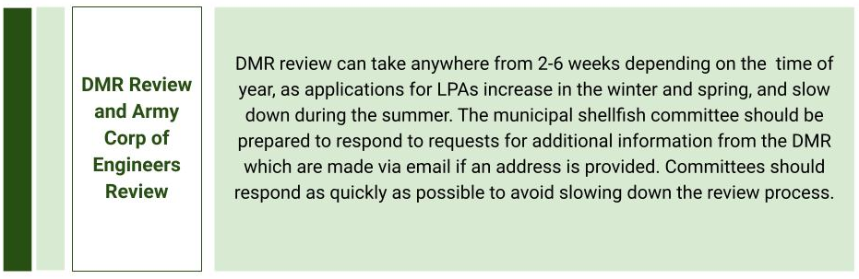
Timeline for the LPA Process. The timeline highlights the various steps needed to complete a LPA application.

Application Forms

The most updated version of application forms is available on the DMR website below:

https://www.maine.gov/dmr/aquaculture/forms/index.html

On that web page, you will see multiple application forms and links. Click on the link titled “Limited-Purpose Aquaculture (LPA) License Applications and Forms.” This will take you to this page, here. The link is also below:

https://www.maine.gov/dmr/aquaculture/forms/lpa.html

Note: Application forms are often updated, be sure you are using the most up to date available. The application forms posted at the links above will be the most up to date.
At the top of the page you can download the application as a PDF. In that version you would print it out and fill it out by hand. You can also download the application as a word document that you can edit on your computer.

Filling out the Application

In this section the guidebook will go page by page through the entire application document. Please note, DMR’s aquaculture staff are available to answer questions about the application and process. For questions about LPA license or application process, please contact: Flora Drury (DMR) by email: flora.drury@maine.gov.

First, on page i of the application form, there are a number of directions in terms of how to fill out the form. It is important to fill out the application form in black ink. There is a nonrefundable $100 fee for submitting the application.

There is also an application checklist on page ii, which should be used to make sure you have all of the application materials required. A copy of this is posted below.

For all LPA applications it is required that you have:

- A check for the application fee payable to “Treasurer, State of Maine”
- Vicinity Map with required items shown
- Overhead view gear map depicting the layout of the gear from overhead
- Cross-section view map depicting gear & moorings from the side

For all sites that are within 300’ from shorefront property (measured from mean low water), you also need to have:

- Tax map certified by the Town Clerk
- Riparian list certified by the Town Clerk
- Copies of receipts for sending certified mail to riparian landowners

Before continuing with the application, please carefully review the “REQUIREMENTS AND RESTRICTIONS FOR LPA LICENSES” and “IMPORTANT INFORMATION FOR LPA LICENSEHOLDERS” on pages iii and iv of the application document.

General Information

Starting on Page 1, under “GENERAL INFORMATION” you can start to list out various details about you. Under the current system, a municipal shellfish committee can list themselves as the applicant. Under assistants, you can list up to three individuals who can work on the LPA, this generally would be key team members. When writing into “Location of License Site” the body of water is more general, (ie: Casco Bay) and the additional description would be the closest shoreline, (ie: East of Hog Island).

For LPA Health Zone, you can navigate to the website below.

https://www.maine.gov/dmr/aquaculture/forms/documents/lpahealthzones.pdf

You can also check the map below:

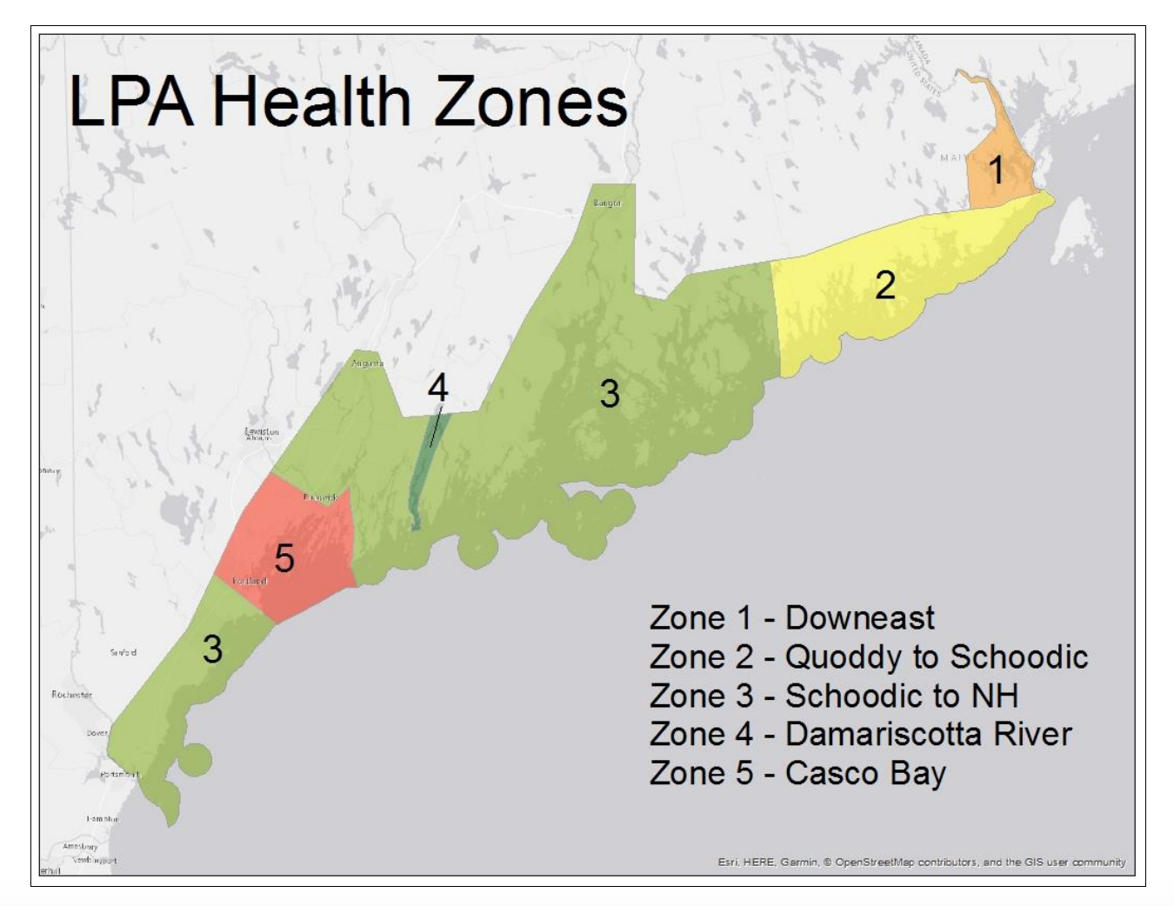
LPA Health Zone Map. The above map is copied from the DMR website. It shows which LPA zone parts of the coast are considered.

Species and Source of Stock

In the section titled Species and Source of Stock” on page 2, you should identify what species you will be working with on the LPA.

Starting from left to right in the table, in the first column you should check each species you will be growing. In the third column titled “Source of Stock” you need to copy the address of where you are getting seed if you are getting seed from a hatchery. If you are using either Muscongus Bay Aquaculture, the Downeast Institute, or Mook Sea Farms you can also check the box for approved hatchery in column 4. If you are moving seed from one growing area to another, you can check the “Wild” Same LPA Health Area box in column 5. However, if you are moving seed from an area in a different LPA Health Area (based on the map above) you can check the “Wild” Different LPA Health Area (Transfer license Required) box in column 6. Please note to move seed across zones you will need a transfer seed license.

To start the process for a transfer seed license, contact Marcy Nelson at DMR prior to placing anything on your LPA site at marcy.nelson@maine.gov or 207-633-9502

Water Quality Information

For Water Quality Information on page 3 of the application, please visit the website for DMR Shellfish Sanitation and Management by using the link address below.

https://www.maine.gov/dmr/shellfish-sanitation-management/closures/index.html

When you click the link above you will find a large list of growing area closure notices and maps. Locate your area, and click under the bacterial notice map column (the second from the left) to find the growing area code, and specific zone. The growing area code is at the top of the map, and the specific zone is above the area. For example from the map below, a growing area designation would be WD(A). Please note even if you are not applying for a LPA in a prohibited zone, you must check the box that you recognize only seed can be grown there.

Example Growing Area Map. This is an example of a growing area map found using the link above.

Alternatively, you can also use the Aquaculture GIS Map which we describe in the next section. This would entail loading the Aquaculture GIS Map, navigating to layers, clicking the MaineDMR NSSP checkbox, and then selecting the closure area nearest to your proposed LPA.

Coordinates

Also on page 3, you need to fill out the “Coordinates” section. You can find your coordinates using google maps, and clicking the area in which you will be putting the LPA. Once you click in an area, a white box will appear with the coordinates in decimal degrees.

You can also find coordinates by using your smartphone GPS while standing in the proposed license using maps, compass, or a similar application.

Site characteristics

On the top of page 4 of the application, there is a table labeled “Site Characteristics”.

Surrounding Uplands and Bottom Characteristics: Please visit your potential site and describe in a few words what the bottom and upland areas look like. This could include: forested, or populated for upland areas, or mud, rocky, or shellhash for bottom characteristics.

Depth, Essential Habitat, and Eelgrass: Use the Aquaculture online GIS map (link below) to find known essential habitat and eelgrass beds. The DMR also prefers you make physical observations for eelgrass as well.

https://maine.maps.arcgis.com/apps/webappviewer/index.html?id=b846cf37b1d64c988f89eafa085c8b7a

Please note, this map can take a few minutes to load completely. To navigate this page, you can review some instructions by clicking here. These instructions demonstrate how to use layers (which show where different datasets such as eelgrass beds or bird habitat), printing and measuring on the map, as well as how to draw the lease you hope to apply for. You can also use the National Oceanic and Atmospheric Association (NOAA) chart layer to designate the depth at mean low water and depth at mean high water. Using the layers in this map, you can answer the questions in the site characteristics table including water quality, essential habitat, eelgrass presence, and others. Note, that the dots designating pending leases are not accurate descriptions of the entire space that lease could take up.

Existing Uses

Also on page 4, there is a second table where you will list existing uses. To fill out each row, you need to provide a detailed description of different activities going on in and around the proposed LPA site, including commercial fishing, recreational fishing, boating activities, and any other activities such as kayaking or swimming. As it states on the form, try to include as much detail as possible, including frequency, season, and amount of any activity. This section will also need a signature from a local harbormaster to certify what you have listed is correct.

Vicinity Map

Starting on page 10, you are asked to develop a vicinity map. Each vicinity map must include the following: the location of the site, a 300 ft. radius circle around the site, a 1000 ft. radius circle around the site, a North Arrow, depth contours, mean low water, mean high water, ebb and flood directions, a scale, distance to any DMR water quality closure lines, and gear orientation.

Drawing the map: Using the Aquaculture Online GIS Map, as described above, you can use the measuring tool to check 1000 ft around your proposed site. You can also use Google Earth to create vicinity maps or you can photocopy NOAA charts and draw by hand using a compass and other drawing tools. NOAA charts have a majority of this information, so they are a good starting point for the vicinity maps. Below, the MSLN project coordinator, Gabby Hillyer, developed a walkthrough video for drawing vicinity maps.

https://drive.google.com/file/d/1nND7ICvhDPK5zCI760shU1l7bUNDFSqz/view?usp=sharing

The video above describes how to draw vicinity maps in the Aquaculture Online GIS Map and Powerpoint, which is the more commonly used mapping software for this part of the application. The video runs at 30 minutes long. The entire drawing process using the technique presented should take about the same time. It goes through step by step how to add drawing components to the Aquaculture Online GIS Maps and transfer it to Powerpoint to add labels. The area chosen on the map should not be considered an endorsement for aquaculture in that area, but instead was chosen at random.

Label: You need to identify any of the items on page 10 that are within 1000ft of your proposed license area. To do this, you can load the Aquaculture Online GIS Map, add in the layers using the layer list button, and then use the measurement tool to check if they are within 1000 ft. of the site. If they are, you need to indicate how your LPA would impact each item. These items include moorings, state and federal beaches, navigational channels, beaches, and others. If none of the items are applicable, you can check “None of the above” at the bottom of the page.

Gear Description

The application lists a number of gear types on page 12. After determining what type of gear you will be using in the LPA, you need to check each gear category and list individual gear types. Try to be as specific as possible for the table, as the more detail added here, the less likely follow up clarifying (and time consuming) conversations will be. This is also the most important section for the Army Corp license approval process. Some examples are provided on page 12. After determining which gear you will be using, you also need to check the applicable boxes at the bottom of page 12.

Individual Gear Type: On page 13 of the application, fill out tables describing the gear type and number used for each type of gear checked on page 12. In the first column of the first table highlight gear type and number used, in the second column add dimensions for each individual gear type, and then provide dates the gear will be in the water.

Bottom Table: In the second table on page 13, provide a maximum dimension for your gear layout, what types of mooring/tackle you will be using for your gear, and if there are seasonal changes to your gear deployment. Please note the outer dimensions of your gear layout cannot exceed 400 square feet.

Overhead View and Cross-Sectional View of Gear Layout

In this section, illustrate what your equipment will look like both looking down onto the site, and from within the water column. Include, describe (providing dimensions) and label rope, buoys, anchors wherever they will be used and visible. Illustrate a different version for each showing any seasonal changes that will be made. You can draw these by hand as long as all information is legible.

Required Signatures

As described on page 16, there are multiple people who have to sign off on the application. This includes the harbor master (or a town official if there is no harbor master), a marina or lobster pound owner (if applicable) any riparian landowners of the intertidal zone (for sites above mean low water) and the shellfish committee chair (for sites above extreme low water).

Riparian Notification

On page 17, the application form statesthat for all sites within 300 ft of shorefront land you are required to notify riparian landowners. This notification includes sending a copy of your application to all riparian owners whose properties are within 300 ft. Most likely all intertidal LPA applications will require riparian notifications. However, you can check your vicinity map to be sure it falls within 300 ft. The PDF linked below describes the process to identify riparian ownership.

https://www.maine.gov/dmr/aquaculture/forms/documents/RiparianDetermination.pdf

Riparian Owners List: For the Riparian Owners list on page 19, include the current owner’s names, mailing address, and the map and lot number for each land parcel within 300 ft of your proposed LPA. Contact your town clerk or municipal tax collector for a parcel map. Using this parcel map, first, mark where your LPA boundaries are, and then identify all of the landowners within 300 ft of the proposed area. For each land parcel within 300 ft, you need to fill out an additional row in the column on page 19 or page 20. You can use as many copies of this sheet as necessary. Once that list is complete, you need to have it certified by the Town Clerk. Please make sure the Town Clerk certifies each page that is used.

Print out and mail a copy of the completed application, as well as page 16 to landowners using certified mail. Make sure you keep receipts of the certified mail. The receipts are a required attachment for the application. Please note, you can also include a letter from the municipal shellfish committee to riparian landowners, perhaps explaining more about the project.

Please Note: You do not need to limit what you send to riparian landowners to this application. You could, and are encouraged to add letters or other documents that can provide more context for the project, particularly the benefits of the project for the community and shellfish harvesting.

Application Signature

Your signature declares the information provided on this form is true and correct.

Submitting your Application

Once your application is complete, please review each section of the application to make sure each piece is filled out and review the checklist provided on the bottom of page 21.

As a final step, send the application and other materials to:

DEPARTMENT OF MARINE RESOURCES
ATTN: DMR Aquaculture Program
Department of Marine Resources
32 Blossom Lane
Augusta, ME 04330

Once both the application materials and the application fee are received, DMR will send your application to the Army Corp of Engineers and the local lobster zone representative. Individual members of the DMR Aquaculture Program review the application, and contact you with any questions or edits to make. Please be responsive to any questions the DMR Aquaculture Program reviewers may have as the more responsive you are, the faster the application may be approved. After all edits are made, the DMR will make a final decision on your application. Along with their decision, the Army Corp of Engineers will also send along a decision and if approved send you the corresponding documents. You must have both approved licenses before conducting any conservation activities in the space. In addition, the Army Corps will require documents notifying them that the project has been started and when it is finished.

Renewal Process

Each year, LPA licenses need to be renewed. In the fall of each year, the DMR will provide additional information on how to complete a renewal application and educational requirement. After submitting a renewal application, starting in mid-December each year, the DMR will send you invoices for your renewal fee ($100). You will also be sent information about the mandatory training, either online or in person.

Final Recommendations

In general this process does take a substantial amount of time and effort on the part of the applicant. For a conservation project run by a municipal shellfish committee, it may be worthwhile to break up the application into pieces, and draw on committee members to tackle individual components. Municipal shellfish committees should also contact their local Area Biologist who may be able to help answer questions or alternatively develop things like the vicinity map or other technical portions of the application. Municipal shellfish committees can also contact the DMR aquaculture staff directly to answer any questions or help with the application process. Municipal shellfish committees or others planning conservation projects should also be proactive in applying for an LPA. This may even mean applying for an LPA before a small grant in order to have all of the permits in hand before the grant payment cycle begins.

Overall, conservation projects that require an LPA are an important part of municipal shellfish management. Municipalities engaging in these projects can continue to learn new information that can help improve the future of shellfish programs and intertidal mudflats. Shellfish committees should use the recommendations and resources provided to help ease the burden of the application process. The hardest application to fill out is the first!

